Razorback Design Document

PDF Fox
Version 0.1
12/31/2011
Table of Contents
Introduction 3
Customer Focus Statement 3
Requirements 3
Parse PDF Files 3
Detect Common Vulnerabilities 3
Identify and Decode Streams 3
Identify Javascript 3
Implementation 3
Metrics 9
Target Impact 9
Future Work 9
Enhancements 9

Introduction
PDF Fox is a full PDF file format parser and detection tool.

Customer Focus Statement
This tool is being developed in order to provide a means of including Sourcefire-authored detection into the Razorback system. As such, in addition to the command line frontend, there will be a nugget version of the tool readily available.

Requirements

Parse PDF files

PDF Fox must be able to parse PDF files deeply enough to be able to extract enough information to scan for malicious behavior as exhaustively as needed. This includes stream types, stream data, javascript, and arguments to the stream, as well as the ability to resolve indirect references (e.g.: 14 0 R).

Detect Common Vulnerabilities

As the end goal to parsing through each PDF file is to be able to reveal any malicious activity therein, the application will require a detection module that will process the relevant parts of the PDF handed off to it by the parser module. This detection module should come preloaded with already-integrated detection for a large list of known CVEs.

Identify and Decode Streams

A majority of vulnerabilities tend to occur in streams, a mechanism within PDF for embedding arbitrary data. To further complicate matters, streams may be encoded, compressed, or even encrypted, sometimes by multiple different algorithms.

The tool must be able to locate stream data and identify the format of its contents (if it’s a known type). This data must then be decoded according to whichever filters are specified for that stream before the resultant, raw data is passed along to the detection module.

Identify Javascript

Javascript is a special case of arbitrary data that may be found inline in objects of dictionary type. Due to its complexity, the true intentions of any included Javascript may be obfuscated, which is why it is especially important to identify it, not only so that it may be run through PDF Fox’s detection module, but also so that it may be re-submitted to Razorback. This way, it can be examined by more sophisticated Javascript tools for any obfuscated maliciousness content that may exceed the current capabilities of PDF to detect.

Implementation
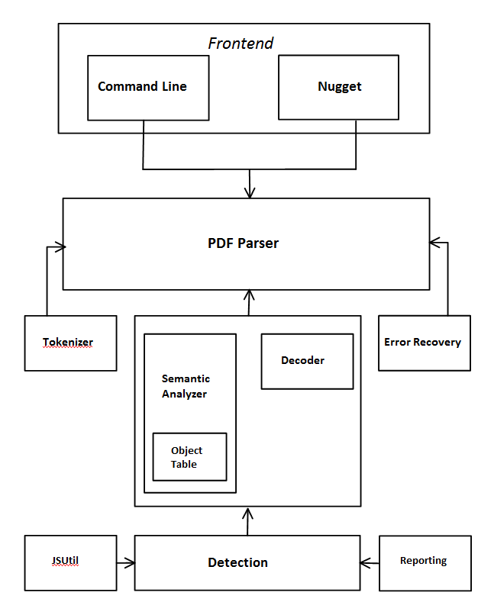
Frontend

The frontend defines the interface to PDF Fox.

There are two frontends: Command Line and Nugget. Each frontend defines values at compile-time that decides how the compiled tool will behave.

In the case of the Command Line frontend, the tool need only accept a file path. This file is then opened and passed along to the core parser. Detection output consists merely of a report to stdout with all the requisite information.

The Nugget, however, is more involved. The nugget frontend must interface with a Master Nugget and, through it, register itself with Razorback. It must signal its readiness to receive files and send detection alert information by means of the Razorback API. Finally, the PDF Fox nugget may elect to reenter sub-blocks back into the system for further analysis.

Lexical Analyzer (tokenizer)

The tokenizer module consists mainly of a deterministic finite automaton (DFA) that accepts a linear sequence of characters and identifies each new sequence as a token. Each time a new token is needed, the parser makes a call into the tokenizer via getNextToken(FILE *), which resumes its work from the current position in the file stream.

Tokens may only be one of the items in the set of all “words” permitted by the PDF file format. These include identifiers, keywords, operators, and literals (such as numbers). The minute a sequence of characters deviates from one of these expected tokens, a NULL is returned and control is returned to the parser to then call the appropriate error recovery or reporting routine.

The tokenizer modules also contains several support functions for tokenizing special areas of the PDF that cannot be processed by the DFA. This includes: stream data, where the length of the content is dependent only on the value in the /Length name modifier, and literal strings, where parentheses can be nested.

Semantic Analyzer (interpreter)

The semantics module consists primarily of functions designed to interpret data and make state decisions on the basis of that data. This includes tracking the length of the stream to be decoded, the filters to use, whether an object contains unresolved indirect references as well as the code to resolve those references.

It is also the module responsible for interpreting object reference and revision numbers, and storing objects in the Object Table.

Syntactic Analyzer (parser)

The Parser is contains much of the core functionality of PDF Fox.

The Parser uses a recursive descent approach to parse a linear stream of tokens (obtained from the tokenizer) according to a syntax or “grammar” defined for the PDF file format. A hierarchical tree data structure is created (a syntax tree) outlining the relationships between all tokens in a PDF file. The structure of the incoming stream of tokens is validated to ensure it conforms with this syntax, otherwise the parser will attempt to reorient itself by calling one of several error recovery routines.

The grammar derived and used by the parser is as follows:

ROOT = HEADER CONTENT
HEADER = PDFVERS | PDFVERS BINHEAD
CONTENT = DATA | DATA CONTENT
DATA = BODY XREF TRAILER | BODY TRAILER
BODY = OBJECT | OBJECT BODY
OBJECT = INTEGER INTEGER obj TYPE endobj
ARRAYCONTENT = TYPE | TYPE ARRAYCONTENT
TYPE = BOOLEAN | NUMBER | LITSRING | HEXSTRING |
NAME | ARRAY | NULLOBJ | REFERENCE
DICTIONARY | DICTIONARY STREAM
BOOLEAN = true | false
LITSTRING = ( litstring )
HEXSTRING = < hexstring >
NAME = item from list of names
ARRAY = [ ARRAYCONTENT ]
DICTIONARY = << ENTRY >>
ENTRY = NAME TYPE | NAME TYPE ENTRY
STREAM = DICTIONARY stream rawbytes endstream
NULLOBJ = null
XREF = xref SUBSECTION
SUBSECTION = INTEGER INTEGER=numrows numrows*XREFTABLE |
INTEGER INTEGER=numrows numrows*XREFTABLE SUBSECTION
TRAILER = trailer DICTIONARY startxref INTEGER END |
startxref INTEGER END
NUMBER = real | integer
INTEGER = integer
XREFTABLE = INTEGER INTEGER IDENT (f|n)
REFERENCE = INTEGER INTEGER ref

As per recursive descent, each syntax rule, or “relation”, becomes a function that must generate one of its respective patterns on the basis of the value of the next token (a look-ahead). Items in the patterns that are themselves further syntax rules are called out to as functions, and they will return a pointer to a subtree. Items in lowercase are terminals.

Unfortunately, due to the nature of the PDF format, the syntactic and semantic layers are not completely separate. Normally, it would be possible to parse a text-based file format using only a look-ahead, but there are derivations in PDF that require interpretations of values that indicate things such as lengths or repetitions, or derivations where a single look-ahead is insufficient because of the manner in which a complex type has been defined (indirect references). These cases are handled specially as they are encountered by the parser, in an ad-hoc approach.

Look-aheads are maintained by the match(PDFTokenType, int) function. The match function ensures the current token matches the token that’s expected by the syntax rule and automatically fetches the next token so that it may be used to make decisions about how to branch. The position in the file before just prior to the next look-ahead token is also maintained in case we need rewind and do error recovery.

Object Table

The Object Table stores the position in the file where an object’s data starts. It’s used to resolve indirect references embedded in PDF objects, but can also be used to locate and reparse any object that requires it.

The Object Table is an array of pointers to entries. Entries are indexed into the array by the reference number of the obtain they refer to. Objects with the same reference number but different revision numbers are linked to one another from the same index via a singly-linked list. Get and Store utility functions are used to add entries to or return entries from the table, and it will grow dynamically based on the number of objects in a PDF that require referencing.

Decoder

The decoder’s only job is to take a pointer to valid data and a length and decode that data according the list of filters specified as parameters to the stream. Once a stream has been decoded, it is swapped in over the encoded data and passed back to the parser so that it can call into the detection module.

The decoder may also opt to call directly into the detection module for vulnerabilities involving the encoding mechanism itself (JPX and JBIG2).

Detection

The detection module is where all of the vulnerability analysis takes place.

The parser (and occasionally the decoder) calls into the detection module through a single function, called Dig(). Dig() takes only three arguments: a pointer in memory to the start of the data to be analyzed, the length of that data in memory, and an enum representing the type of that data (if it can be identified). Each detection function registers itself into an array of function pointers. Dig() iterates through each of these detection functions to operate on the arguments it’s been passed

The detection functions themselves are each specific to a given vulnerability, so the logic therein will vary from function to function. A few general standards are established, however; functions should exit as early as possible when a triggering condition or criterion isn’t met. This means that detections functions that are only concerned with a particular type of data should immediately check to make sure the type of data they’ve been passed is the right type, otherwise exit.

Additionally, once vulnerability triggering conditions are identified, detection functions should call foxReport() to report the details. More on this below.

Javascript-specific detection functions may make use of helper functions located in foxjsutil.c to streamline the detection process.

JSUtil

This module contains javascript parsing and normalization functions.

JSFindFunction() will search a block of javascript for the method name passed as an argument, parse the arguments passed to that method on call, and pass back a structure that contains a count of the number of arguments passed, as well as a vtable with pointers to each of those arguments.

The structure passed back is as below:

typedef struct _JSArgList {
int count;
char **vector;
} JSArgList;

Javascript detection functions that attempt to locate a method in a block of javascript, or ones that must examine the arguments passed to a particular instance of that method being called can make use of this function to streamline detection. The function can be called numerous times with the same arguments and it will return the arguments to the next subsequent call in the javascript block. When the method can no longer be found, a NULL is returned.

Reporting

The reporting module contains only two functions: foxLog() and foxReport();

foxLog() is a general purpose logging function that allows you to log to stdout in a number of different ways for different reasons. In addition to the logging mode, it takes a variable arg list and works similarly to printf(). Among the included logging modes are: PRINT(log exactly), DEBUG(prepend [DEBUG]), NONFATAL(log but don’t exit) and FATAL(log and exit). Undefining any of the the following values will disable the output:

PDF_FOX_SHOW_DEBUG (PRINT, DEBUG)
PDF_FOX_SHOW_NONFATAL (NONFATAL)
PDF_FOX_SHOW_FATAL (FATAL)

foxReport() is used to by the detection module to report any vulnerabilities. In Command Line mode, a message, CVE, and sid for the vulnerability identified will be printed to stdout. In Nugget mode, this function will add the CVE to the Metadata list and call Razorback_Render_Verdict().

Metrics
Number of PDF files parsed to completion
Number of false positives
Number of false negatives
Time to parse and run detection (performance)
Number of fans

Target Impact
The only aspect of this project that affects existing modules is the integration with razorback, however, as PDF Fox is expected to operate as its own standalone nugget, the only real integration issues relate to content management and inclusion of the nugget into our package of existing nuggets.

Future Work

Enhancements
- Additional supported decoders.
- Ability to easily add custom detection in any language.
- Enhanced javascript deobfuscation and normalization utilities.
- More command line options and display modes.
- Ability to choose and view arbitrary objects upon completion of parsing.
- Recursion limit.

